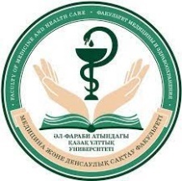****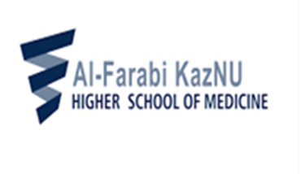

**Instagram: Facebook:**

**@farabi_general_med_practice General Medical Practice**

**Department at Farabi University**

**INFORMATION LETTER**

**Dear Students and Academic Advisors,**

**The Faculty of Medicine and Healthcare** of Al-Farabi Kazakh National University (Al-Farabi KazNU) invites you to participate in the International Student Conference **“Diagnostics and Treatment of Orphan Diseases: Challenges and Achievements”,** dedicated to International Rare Disease Day.

The conference will be held on February 28, 2025, in a hybrid format.

**Main Topics of the Conference:**

1. Orphan diseases: molecular pathogenesis, modern diagnostic technologies, and treatment approaches.

2. Rare and unknown diseases in the practice of physicians from various specialties.

3. Atypical manifestations and complications of common diseases.

4. Rehabilitation of patients with orphan diseases.

5. Clinical case analysis.

**Participants:** Students, interns, master’s students, PhD candidates, residents, and young scientists (under 35 years old).

**Working languages of the conference:** Kazakh, Russian, English.

**Participation formats:** Presenter, attendee.

**Presentation duration:** 10 minutes.

**To participate in the conference, please register by February 20, 2025, via the following link:**

**<https://forms.gle/5xr1kyXNifnA7Lbt6>**

**Abstracts and articles are accepted until February 20, 2025, at the following email address:**

ovp.conference2024@gmail.com

**Guidelines for Article/Abstract Formatting:**

1. Title of the article/abstract.

2. Full name(s) of the author(s) (maximum of five authors).

3. Name of the institution, city, and country.

4. Text structure: introduction, methods, results, conclusion, and references (for articles).

5. Font: Times New Roman, size 12, single spacing, 2 cm margins on all sides.

6. Page orientation: portrait only.

7. Length: abstracts – 1 page; articles – 3-5 pages.

**Guidelines for Poster Presentation Formatting:**

1. Title of the poster.

2. Full name(s) of the author(s).

3. Academic advisor.

4. Name of the institution, city, and country.

5. Main content: introduction, methods, results, conclusion, and references.

6. The poster should be submitted in PowerPoint format (no more than 3 slides).

7. The poster presentation can be displayed on LED screens in the form of a presentation.

We look forward to your participation!